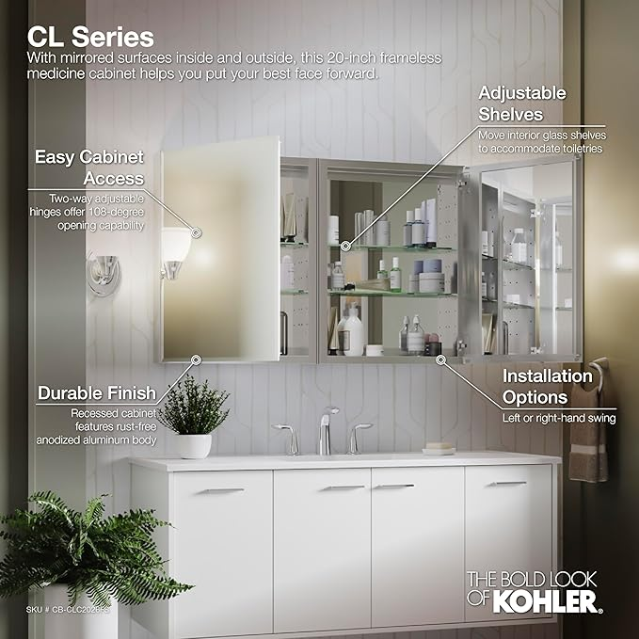

$339

KOHLER K-CB-CLC2026FS Beveled Medicine Cabinet with Mirror Door & Adjustable Shelves, Rectangular Beveled Edge Frame, 20" x 26"